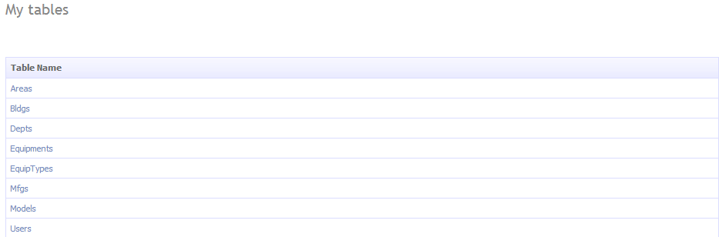

<asp:GridView ID="Menu1" runat="server" AutoGenerateColumns="false"

CssClass="DDGridView" RowStyle-CssClass="td" HeaderStyle-CssClass="th" CellPadding="6">

<Columns>

<asp:TemplateField HeaderText="Table Name" SortExpression="TableName">

<ItemTemplate>

<asp:DynamicHyperLink ID="HyperLink1" runat="server"><%# Eval("DisplayName") %></asp:DynamicHyperLink>

</ItemTemplate>

</asp:TemplateField>

</Columns>

</asp:GridView>